All trained with 2000-2500 steps with learn rate 0.7. The two images correspond to inceptionV3, layer Mixed_6c/concat, index 4 and 7.

**Future plan:** After I got the right color, I would like to optimize the different hyperparameters (layers, epochs, learn rate, etc.) either with grid search or tuning with Bayesian optimization.

**Future improvement:** Data augmentation should be written in a more efficient and modularized way.

1. Luna initialization (pure)

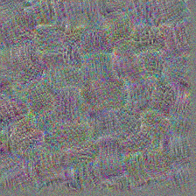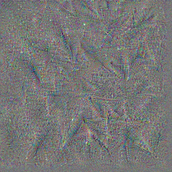

1. 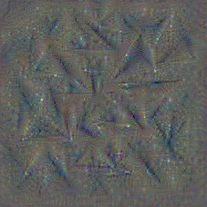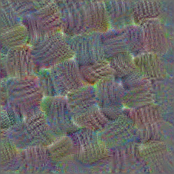Luna initialization + blur
2. Luna initialization + noise

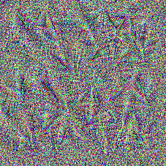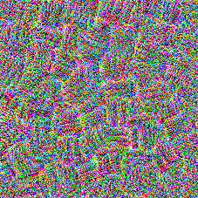

1. Luna initialization + scale

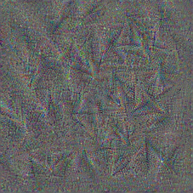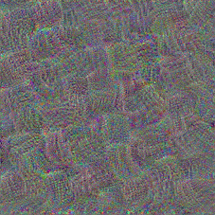

1. Luna initialization + noise + blur

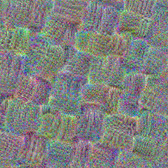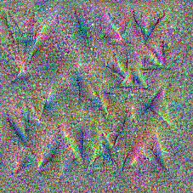

1. Luna initialization + noise +scale 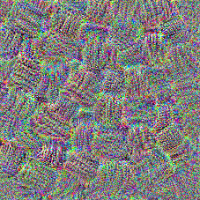

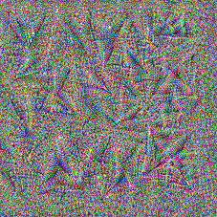

1. Luna initialization + blur + scale

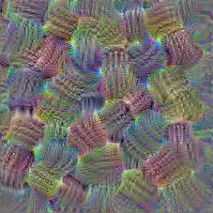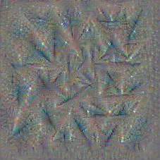

1. Luna initialization + blur + scale + noise

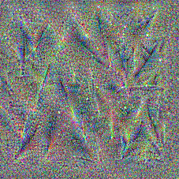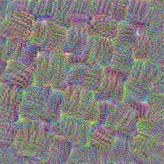

1. Luna initialization + modularized blur / noise / scale

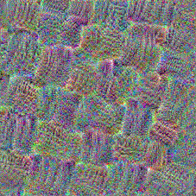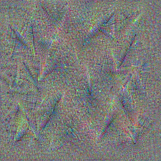

1. Lucid initialization (pure with no transformation)

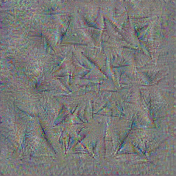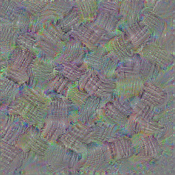

1. Lucid initialization + fft + decorrelation (no transformation)

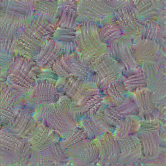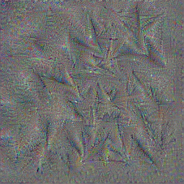

1. Lucid ini + fft + + decorrelation + modularized luna blur/noise/scale

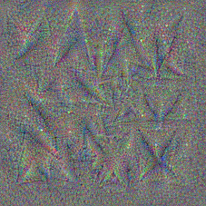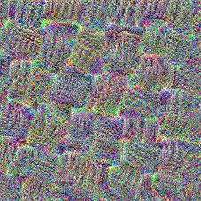

1. Lucid initialization + fft + decorrelation + luna blur + luna scale

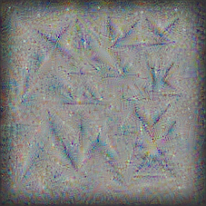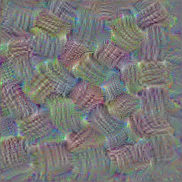

1. Lucid initialization + fft + decorrelation + Adam (apply gradient) (no transformation)

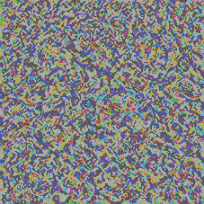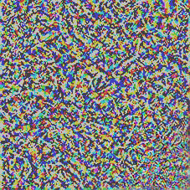

1. Lucid initialization + fft + decorrelation + Adam optimizer + minimize

loss = lambda : compute_loss(img, model, filter_index)

optimizer.minimize(loss, var_list=[img])

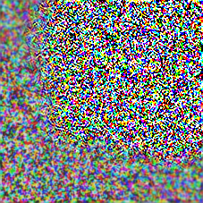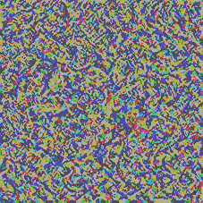

*minimizer will create the tape to compute the gradient and update the parameters for me so I do not need to write the GradientTape anymore (just if I write the applygradient method I should use it)

1. Luna or Lucid initialization without any fft using normal gradient descent with some modifications on image deprocessing and pushing the grads between 0 and 6

The left photo is the original photo and the right one is the output result of luna.

Inception v3 , mixed4, index 29

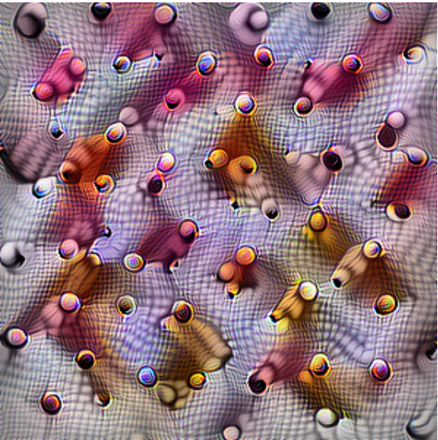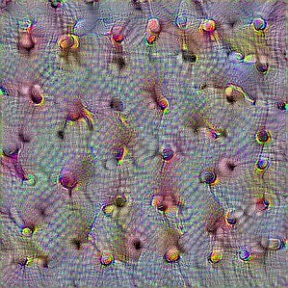

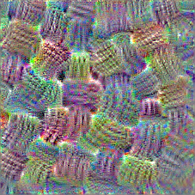Inception v3, mixed5, index 4

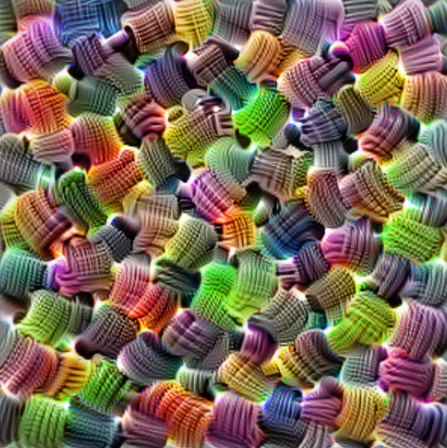

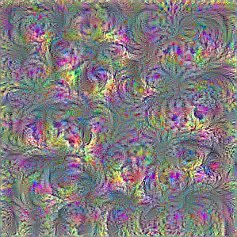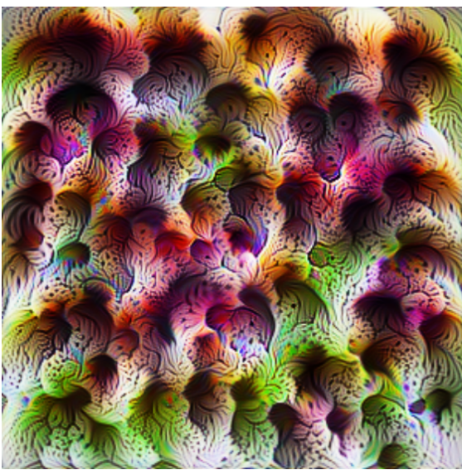Inceptionv3, mixed5, index 19

Inception v3, mixed5, index 23

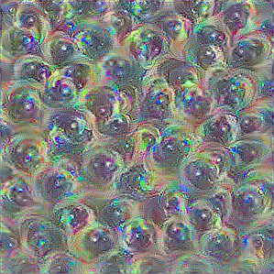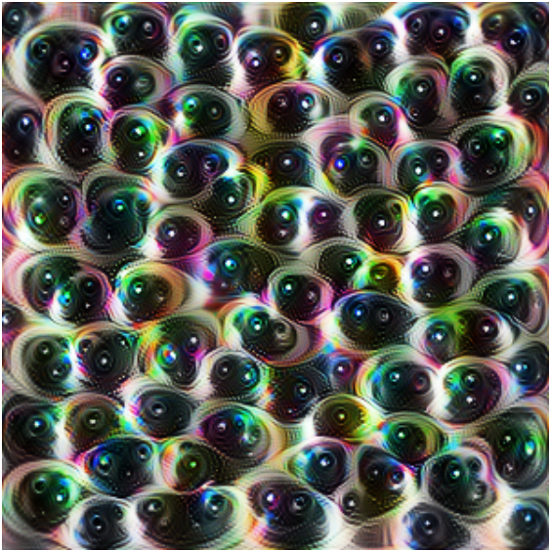

Inception v3, mixed6, index 165

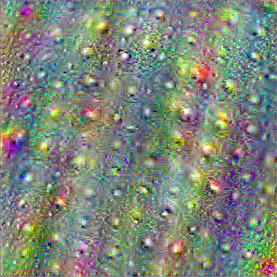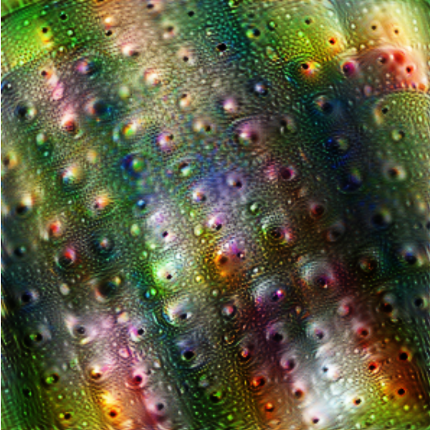

1. Lucid initialization + modular transformation + relu + rotation

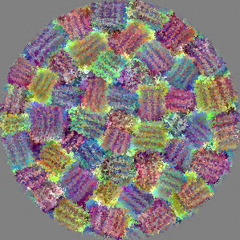

Some “To do” points:

* Relu gradient (Check with Alex whether it applies the modification at all or not (I do not see the difference so far))
* Lucid transformation (add padding and jitter to our transformations)
* Modularized augmentation selection (write a function that can apply different number of augmentations with different numbers at every run) (right now is very rudimentary)
* Maybe try cosine similarity and l2 regularization for getting the loss values

Can I get something beautiful please and write a nice paper? :’(